# **MongoDB Backup and Restore Databases Plugin**

## MongoDB Backup Plugin

### Basic Requirements –

MongoDB in the system should be up and running to work with this plugin.

### How to install plugin –

The simplest way is by going to your installation's management screen and clicking Manage Plugins and go to the advanced tab. Choose the .hpi file from system click on Upload.  Check the checkbox of Install without restart and install after restart.  If you install without restart the interface will show you progress and provide the results of the install. Once that is done, you should see the list of plugins.

This is Build Step Plugin it will appear in list of Add Build Step.

### Parameter to Pass –

This Plugin Takes two parameter

1. MongoDB Path – This is path of folder where MongoDB is installed in your system.
2. Backup File Path – Provide the path to store the backup.

Both path should be passed with single backslash only.

For e.g., D:\Document.

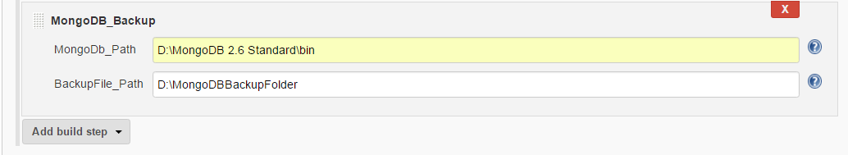

## MongoDB Restore Plugin

### Parameter to Pass –

This Plugin Takes three parameter

1. MongoDB Path – This is path of folder where MongoDB is installed in your system.
2. Backup File Path – Provide the path where the backup is stored.
3. Database name – Provide the name of database to restore.

Both path should be passed with single backslash only.

For e.g., D:\Document.

